Data Analytics (DA)
Module -2
Power BI Assignment 1 – Data Transformation & Data Modeling

1.Data Import & Transformation :-
List of order table
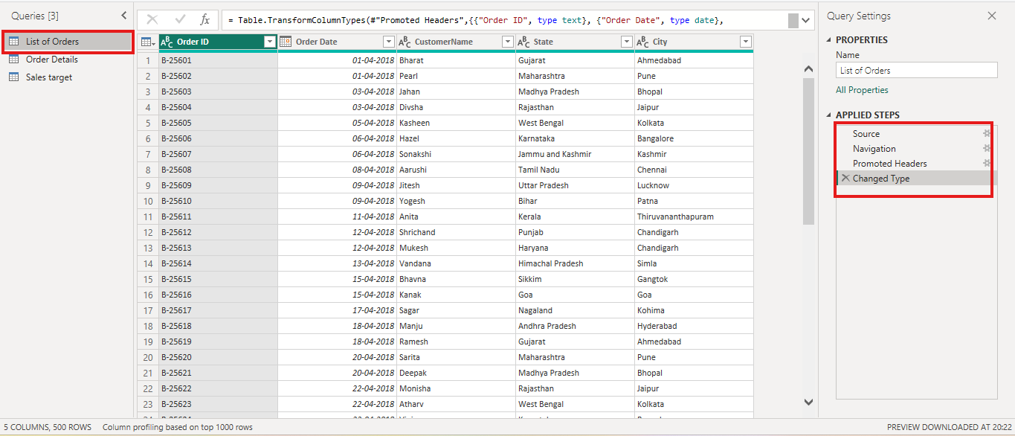
Import in list of order table excel file transformation data data power query editing data type, head of column, navigations.

Order details table
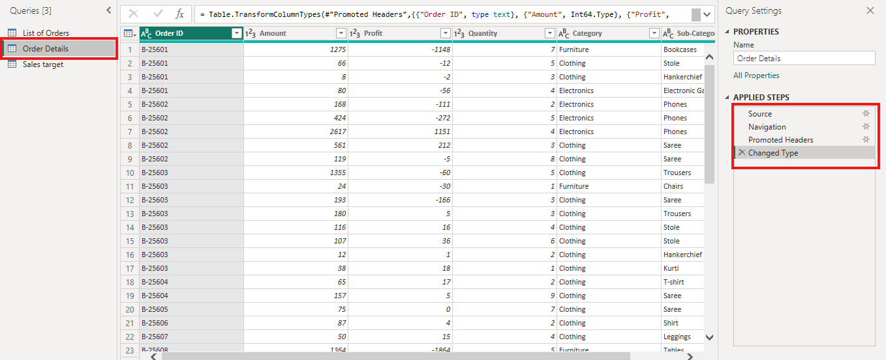
Import in order details table excel file transformation data power query editing data type, head of column, navigations.

Sales target table
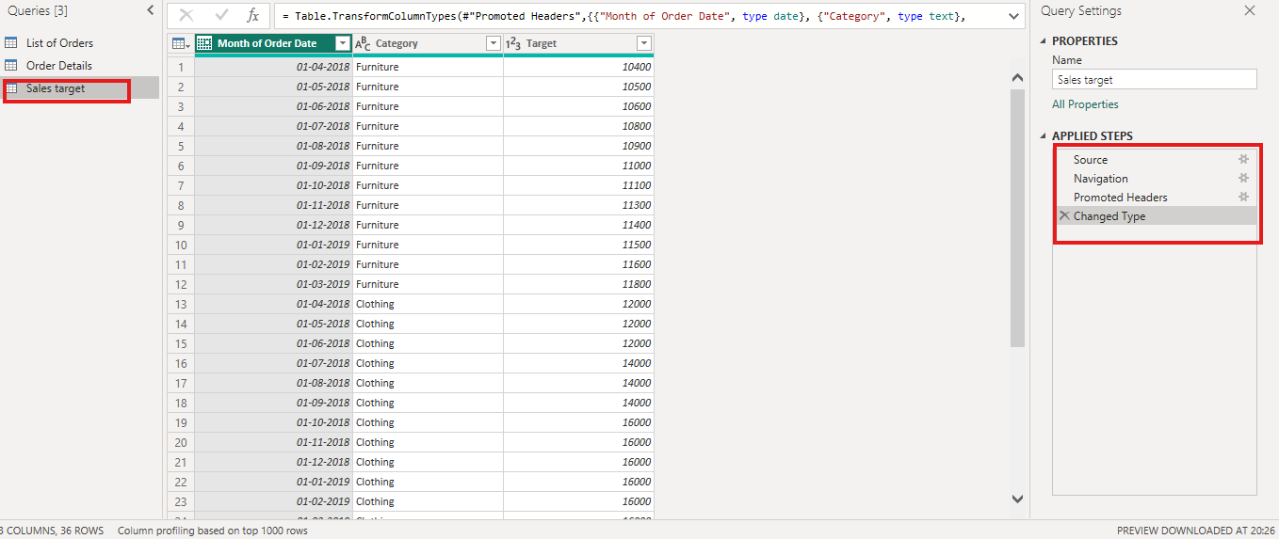
Import in sale target table excel file transformation data power query editing data type, head of column, navigations.

2. Row Limiting & Data Types:
Order detail table
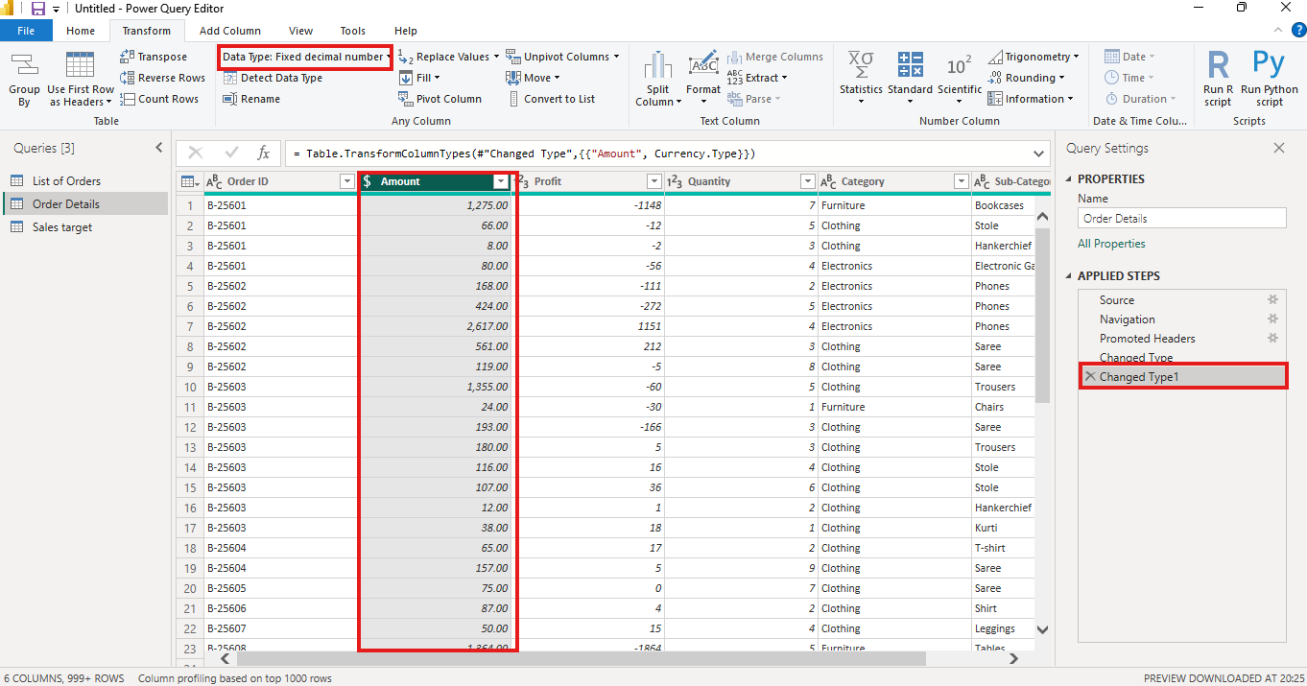
Order details table in amount column data type changed fixed decimal number.

Sales targer table
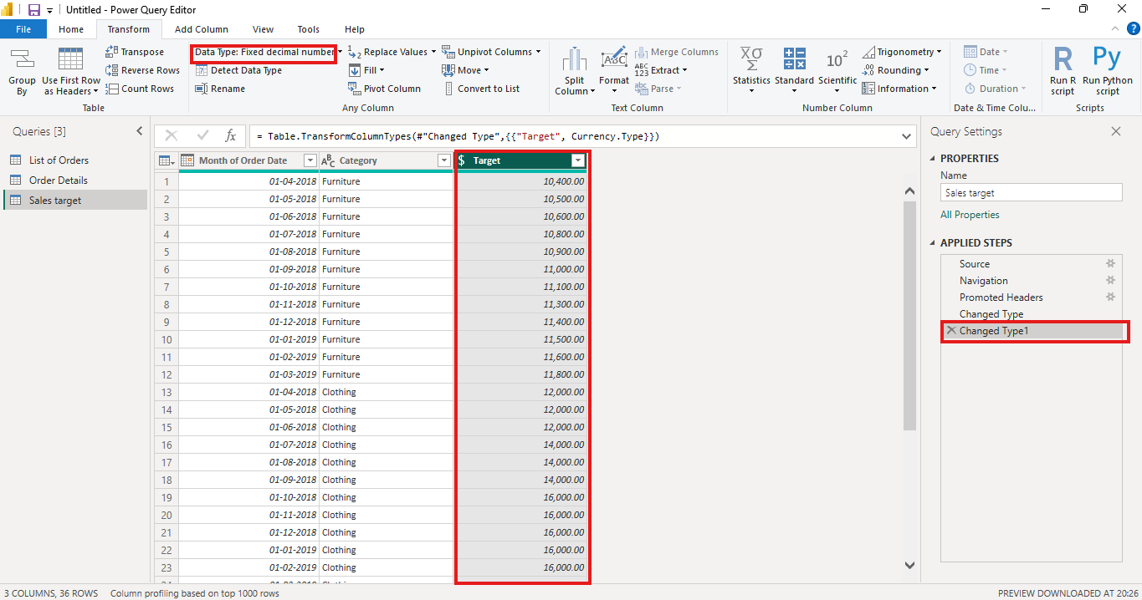This table amount column data type changed fixed decimal number.

3. Text Formatting:
List of order table
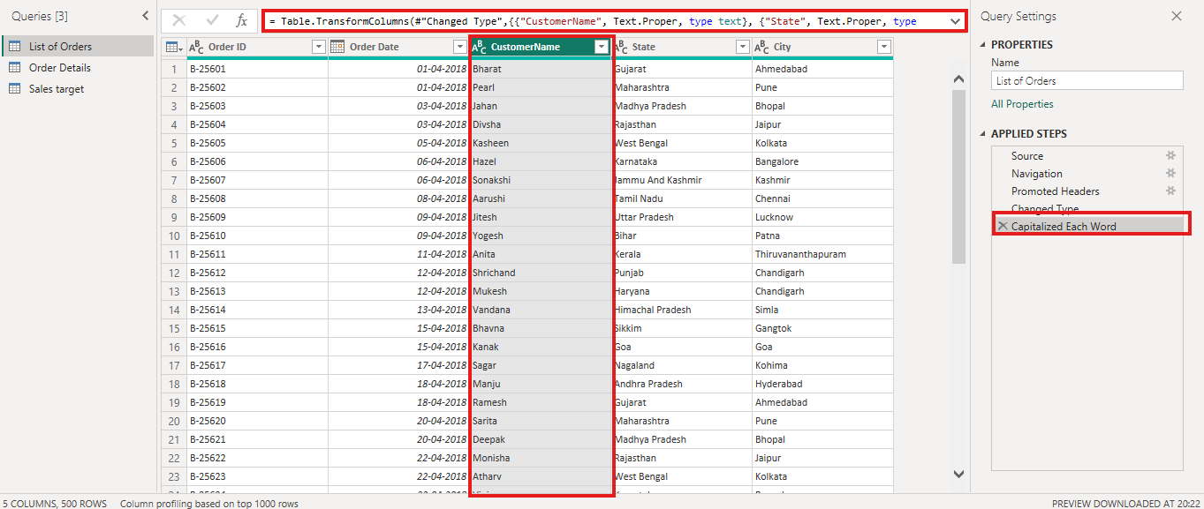This table customer name proper case use in data consistent.

4. Column Creation :-
List of order table
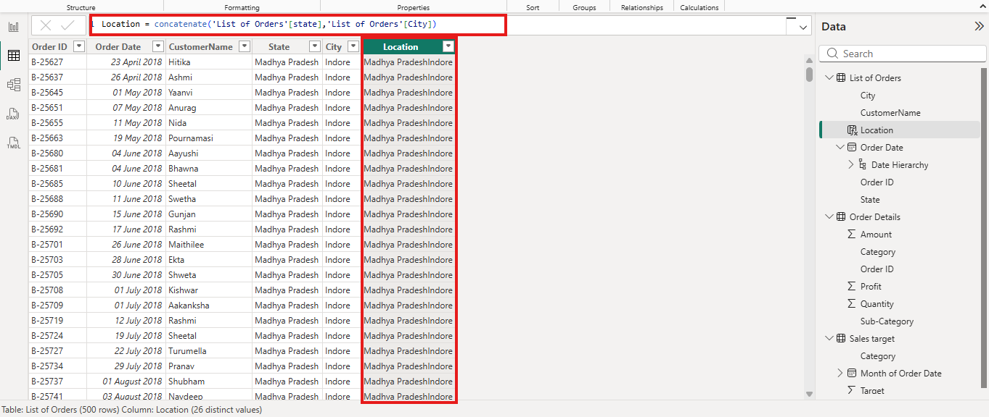
List of order table closed& apply load power bi. before, new column create in use DAX “concatenate “ state and city column name location that.

Order details table
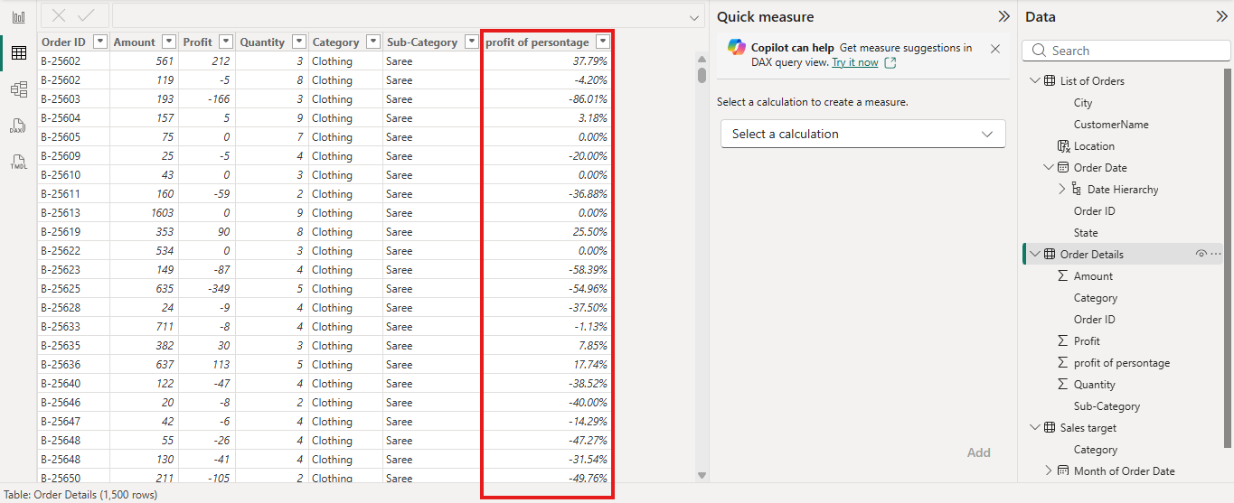
This table new column profit& amount in use custom column devion by that. Before use in change data type persontage% value

5. Conditional Column:-
Order details table
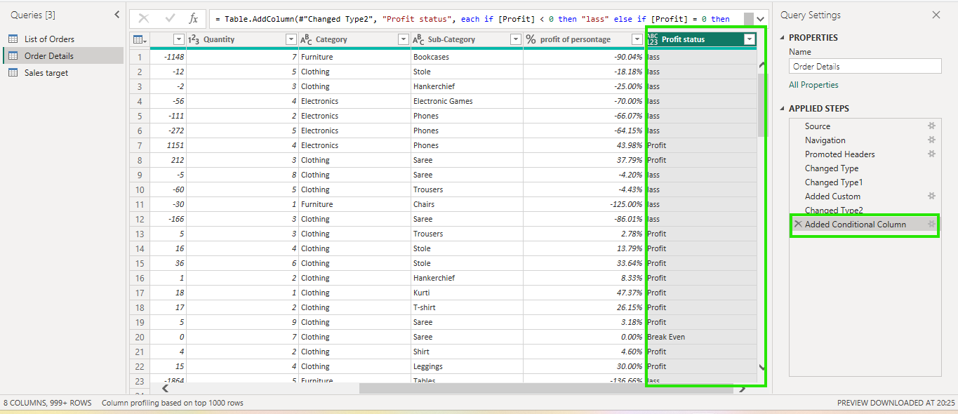
Add a conditional column named Profit Status based on:
■ Profit < 0 → Loss
■ Profit = 0 → Break-Even
■ Profit > 0 → Profit
This condition use in new column create profit status column table.

6. Merging Data (Joins)
List od order and order date
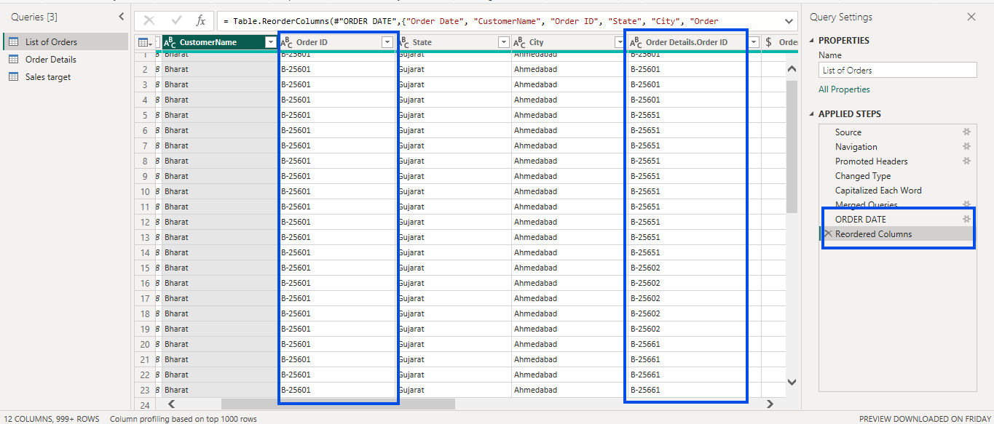
List of order and order details table merge in order id 500 rows order date created
7. Handling Missing Data & Duplicate Data
This dataset no duplicate data and missing values handled chentrale shendance.

8. Sorting and Filtering Data
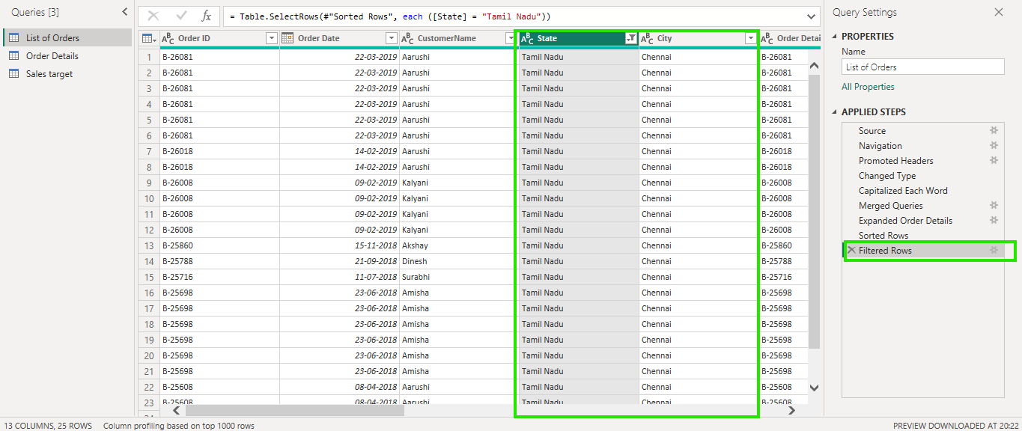
This table in shorting state column tamil nadu

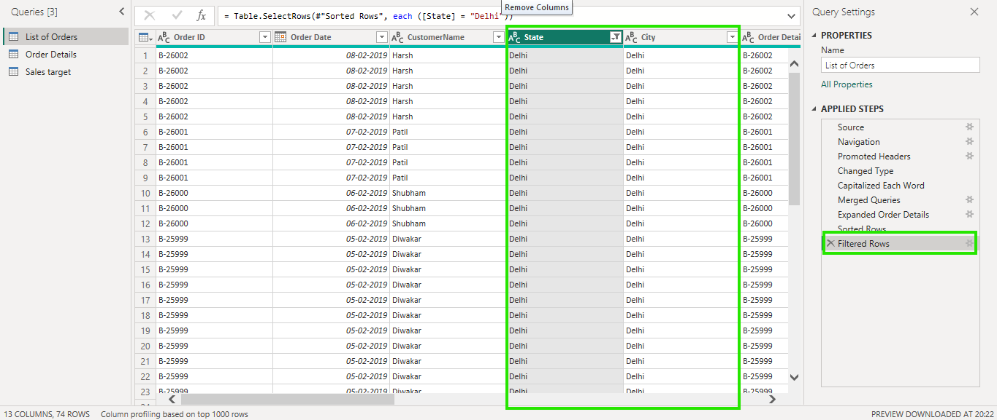
This table in filtering state column Delhi

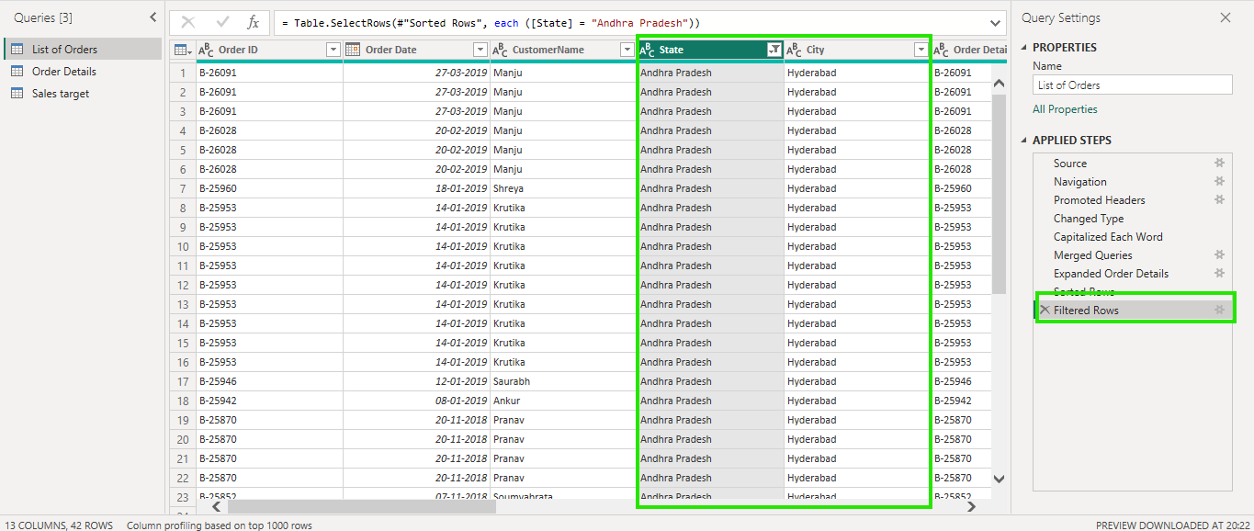
This table filter the state column in Andhra Pradesh data.

9. Grouping and Aggregating Data :-
Count of Order ID
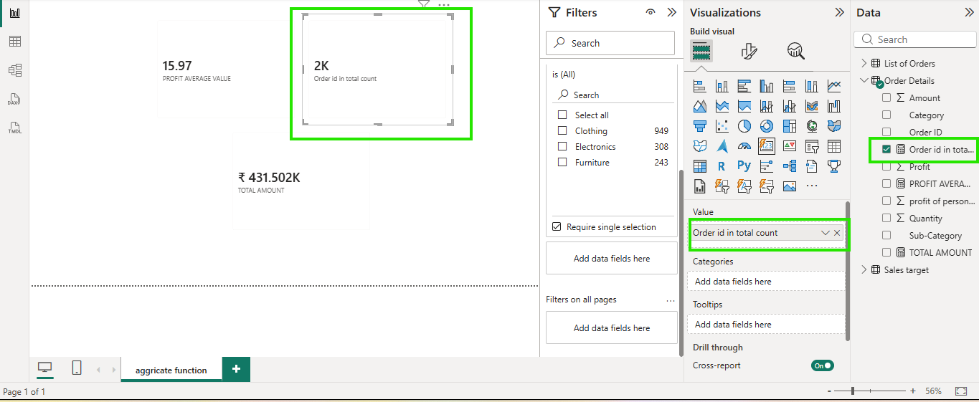
Order details tables create In measure column order ID total count.

Average Profit by Category
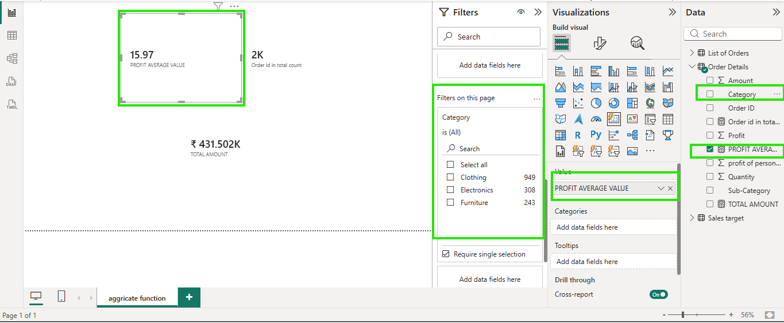
Order details tables the profit value in average wish category filtering

Total Amount by Sub-Category
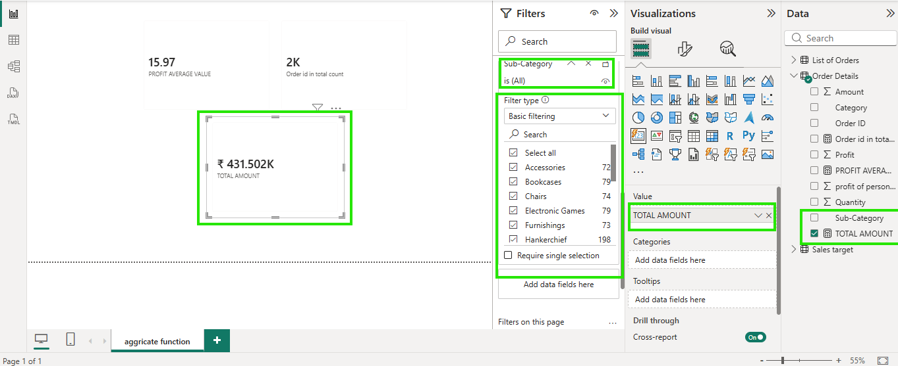
Order detail tables the amount column in total value with sup category filtering average.

Sales target :-
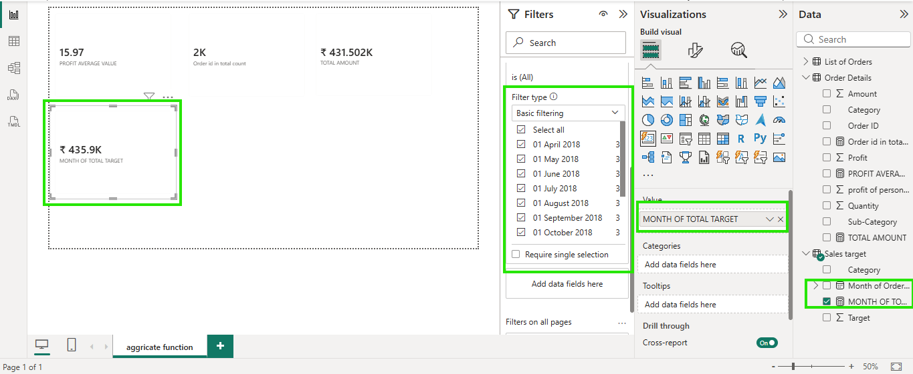
Sales target table target column in total value with month of date wish filtering card visualization.

10. Data Modeling: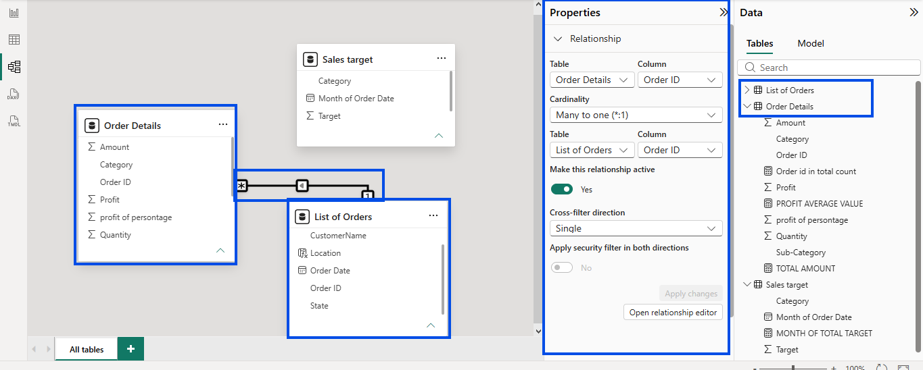
List of order and order details tables relationship create marge in order id many to one in Cardinality type.

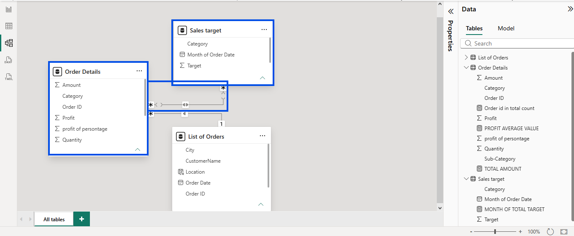
Sale target and order details table common column in category two table relationship many to many Cardinality type.

------------------------END------------------------

